**Database project Phase-04 Submission**

**Project Idea: portfolio terrain – A dedicated social media platform for freelance and remote developers**



**Submitted by:**

**Usman Shahid (L1F22BSCS1057) &**

**Ali Hamza Sehole (L1F21BSCS0791)**

**Section: D-8**

**Submitted to:**

**Sir Afham Nazir**

use portfolio_terrain;

-- nested queries

-- 1. retrieve the latest post content from each user:

select u.username, p.title, p.content

from users u

join posts p on u.user_id = p.author_id where p.date_posted = (

select max(

p2.date_posted

) from posts p2 where p2.author_id = u.user_id

);

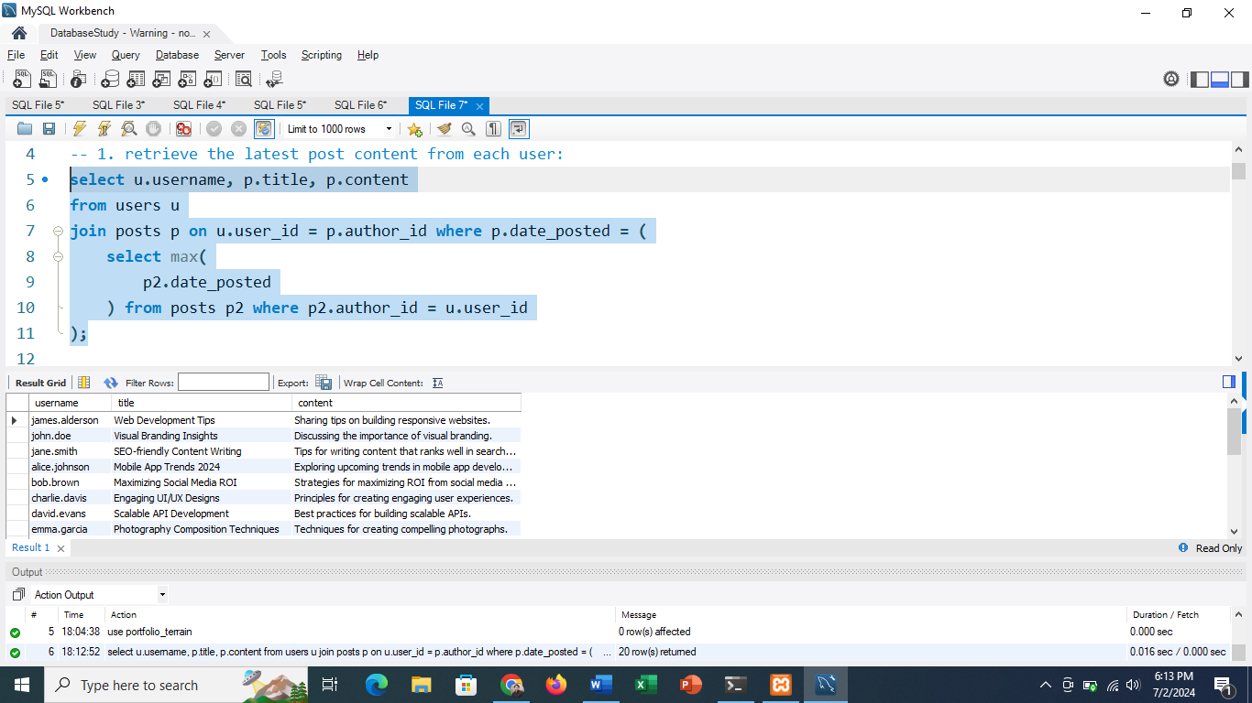

-- 2. find users who have posted in the 'web development' category and the date of their latest post in that category:

select u.username, max(p.date_posted) as latest_post

from users u

join posts p on u.user_id = p.author_id

where p.category = 'web development'

group by u.username;

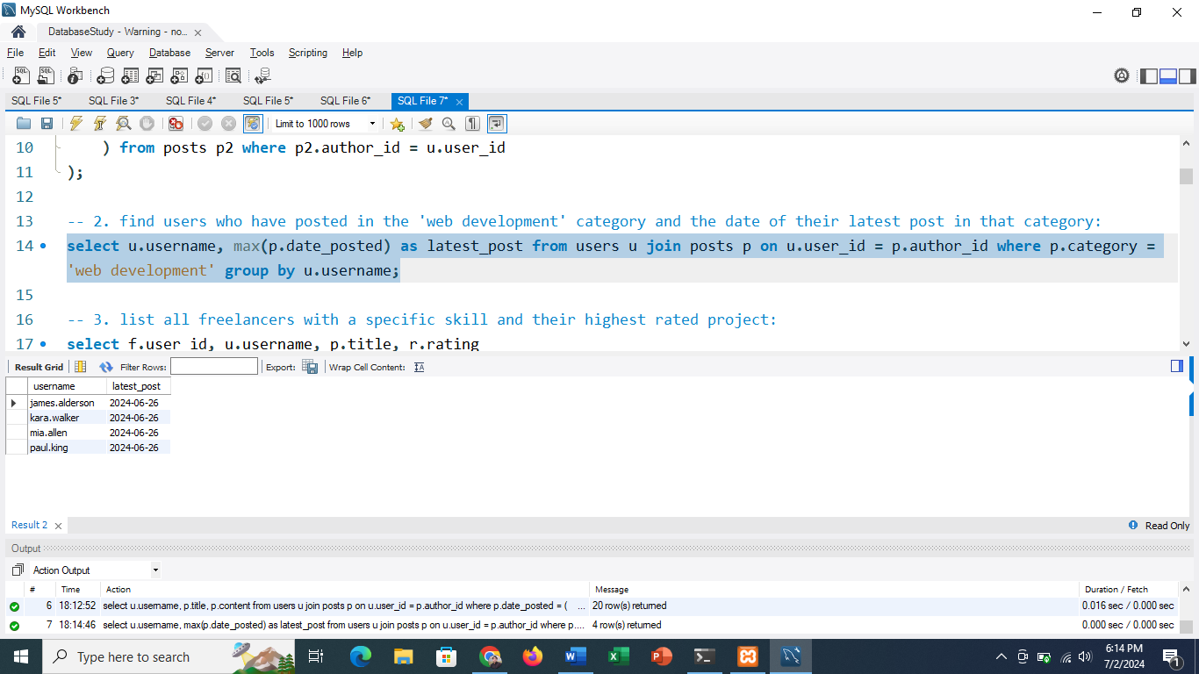

-- 3. list all freelancers with a specific skill and their highest rated project:

select f.user_id, u.username, p.title, r.rating from freelancer f join users u on f.user_id = u.user_id join projects p on f.freelancer_id = p.seller_id join reviews r on p.project_id = r.project_reviewed

where f.skills like '%python%'

and r.rating = (

select max(r2.rating)

from reviews r2

join projects p2 on r2.project_reviewed = p2.project_id

where p2.seller_id = f.freelancer_id

);

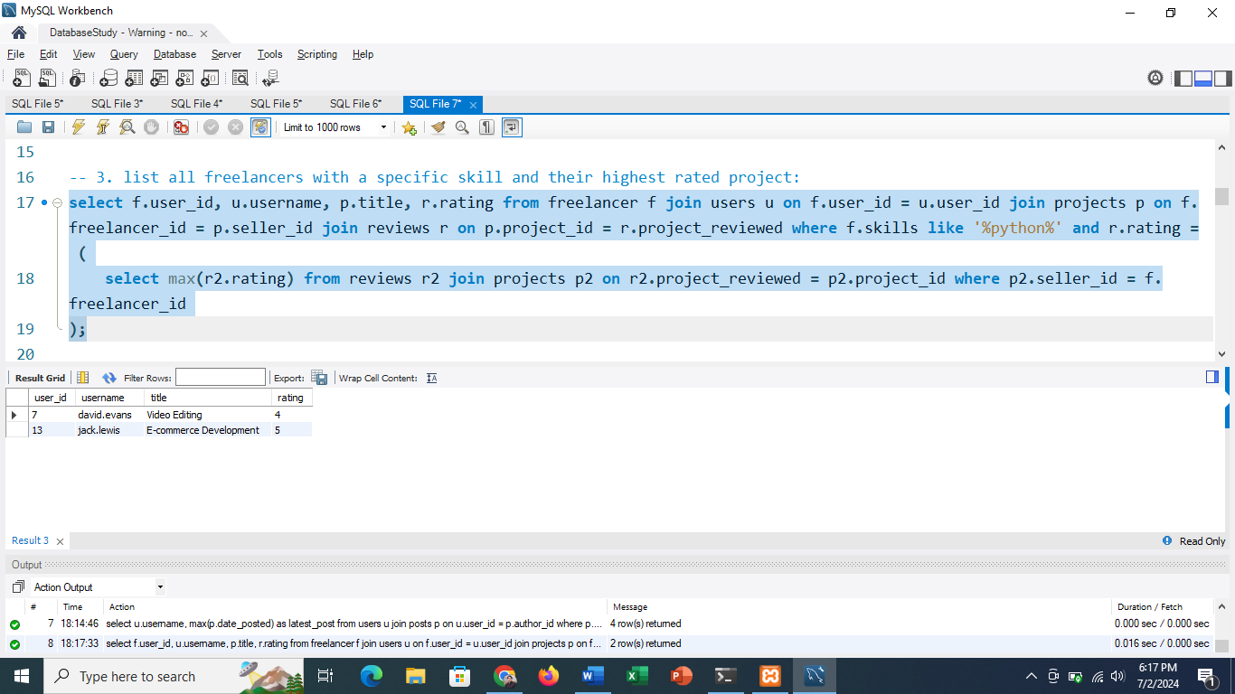

-- 4. find the buyer who has spent the most on contracts:

select b.user_id, u.username, sum(c.cost) as total_spent

from buyer b

join users u on b.user_id = u.user_id

join contracts c on b.buyer_id = c.buyer_id

group by b.user_id

order by total_spent desc

limit 1;

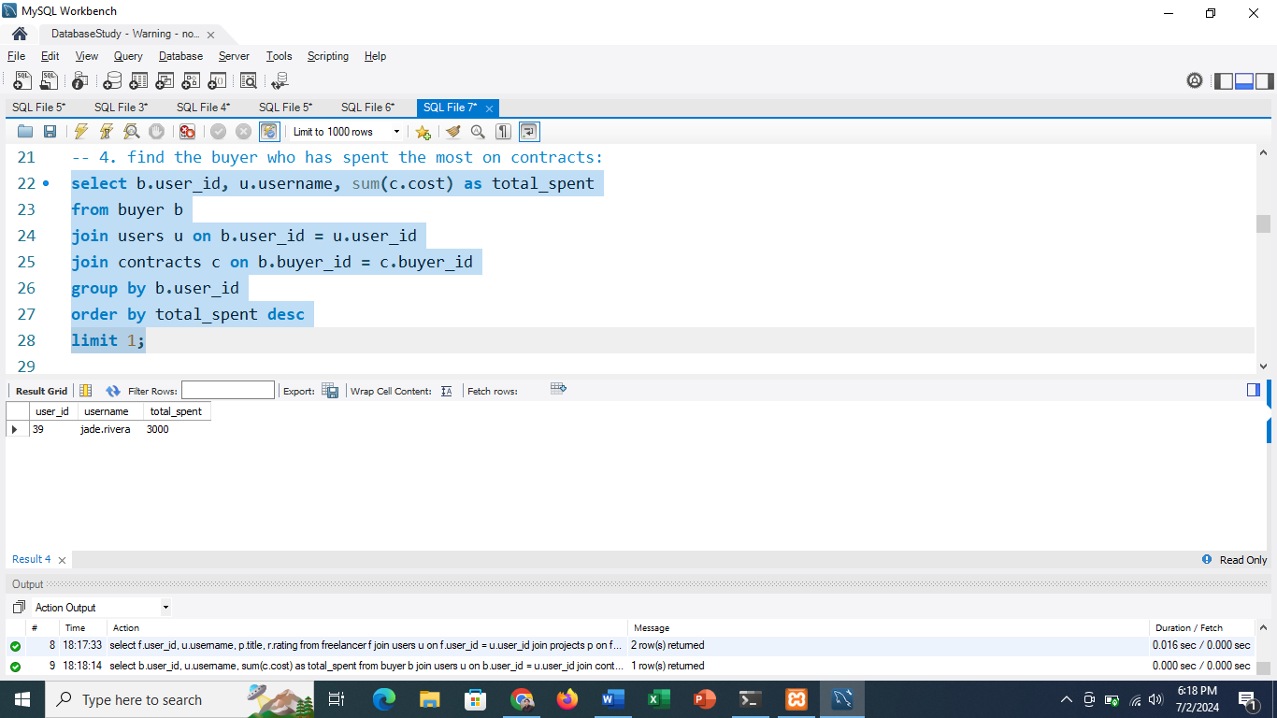

-- 5. retrieve comments on the most liked post:

select c.content, u.username, c.comment_date

from comments c

join users u on c.commenter = u.user_id

where c.commented_post = (

select l.post_liked

from likes l

group by l.post_liked

order by count(l.liked_id) desc

limit 1

);

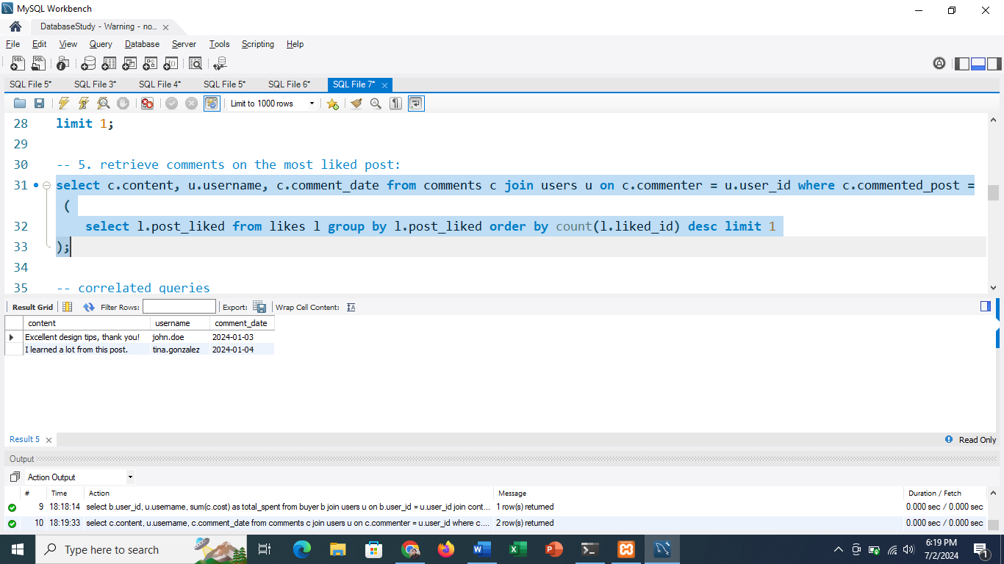

-- correlated queries

-- 1. retrieve all posts along with the number of comments they have received:

select p.title, p.content, p.date_posted,

(select count(*)

from comments c

where c.commented_post = p.post_id) as comment_count

from posts p;

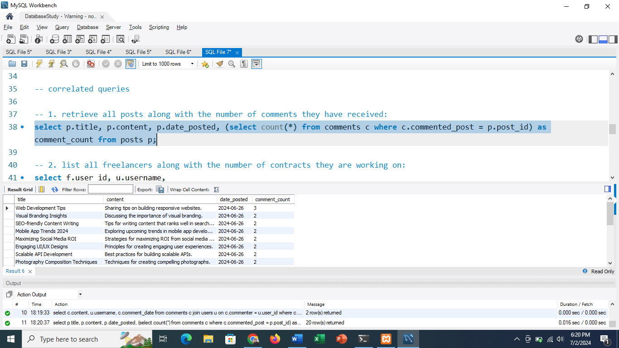

-- 2. list all freelancers along with the number of contracts they are working on:

select f.user_id, u.username,

(select count(*)

from contracts c

where c.freelancer_id = f.freelancer_id) as contract_count

from freelancer f

join users u on f.user_id = u.user_id;

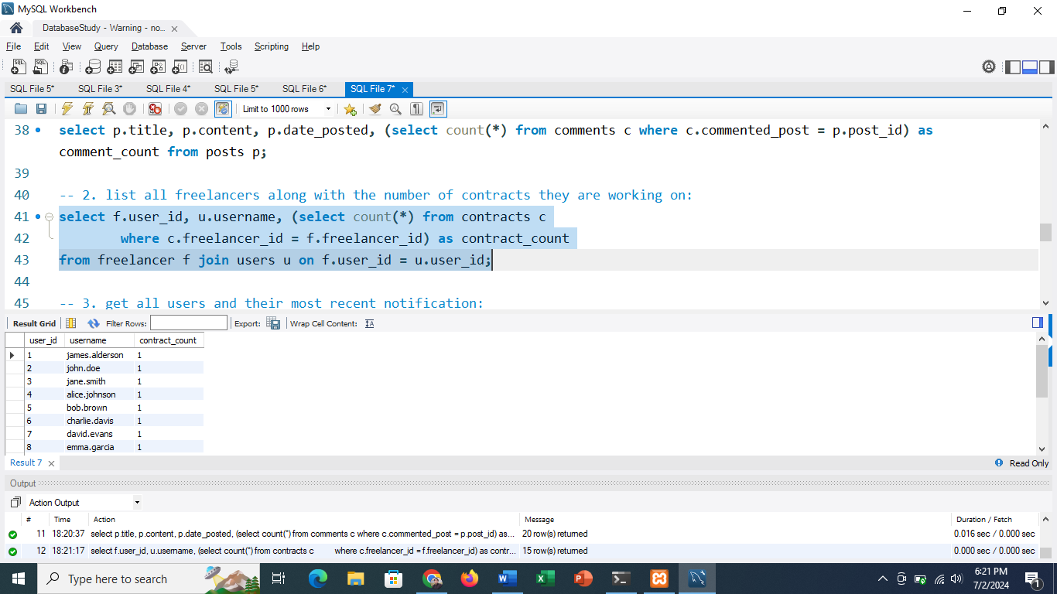

-- 3. get all users and their most recent notification:

select u.username, n.content, n.notify_date

from users u

left join notifications n on u.user_id = n.user_notified

where n.notify_date = (

select max(n2.notify_date)

from notifications n2

where n2.user_notified = u.user_id

);

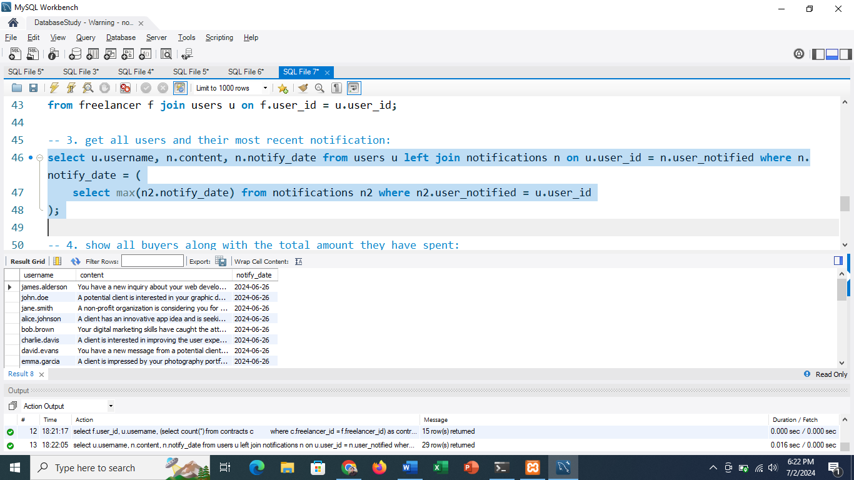

-- 4. show all buyers along with the total amount they have spent:

select b.user_id, u.username,

(select sum(p.amount)

from payments p

where p.buyer_id = b.buyer_id) as total_spent

from buyer b

join users u on b.user_id = u.user_id;

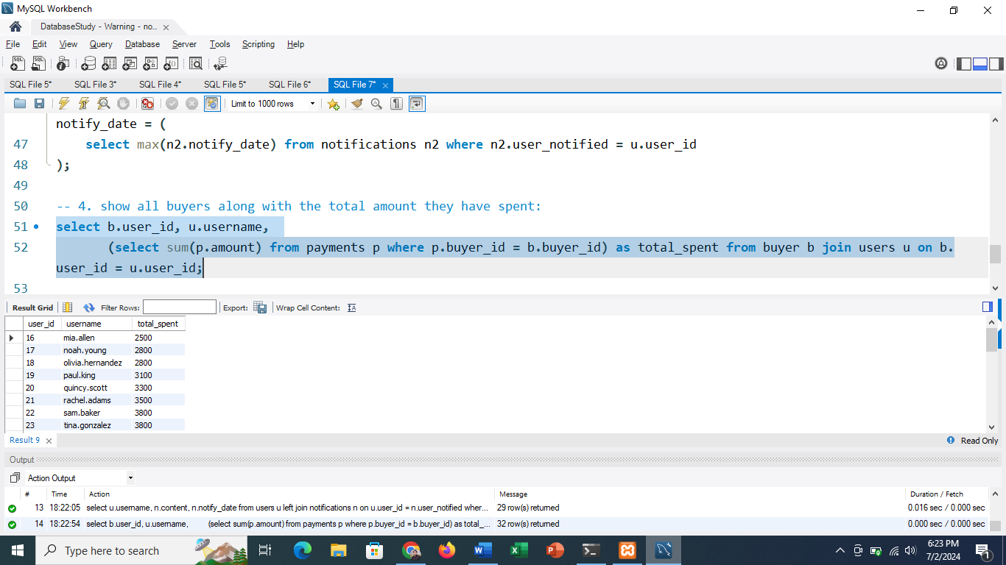

-- 5. list all projects along with the highest rating they received in reviews:

select p.title, p.category, (select max(r.rating) from reviews r where r.project_reviewed = p.project_id) as highest_rating

from projects p;

